Force - 01
CLASS 09 - SCIENCE

 | Section A
1 | Bags at the top of school van are tied using a string to avoid the effect of  a) inertia  b) acceleration  c) force  d) momentum | [1]
2 | A mass M breaks into two pieces in the ratio 1 : 3 while at rest. If the heavier has a speed of v, the speed of the lighter is  a) 3v  b) v  c) 4v  d) 2v | [1]
3 | If force, change in momentum and time are given by F, p and t respectively, then they are related by  a) F = pt  b) p = F$​^{2}$ t  c) $F=\frac{P}{t}$  d) Ft$​^{2}$ = p | [1]
4 | The acceleration of a body is to be doubled from its initial value. By what factor is the acting force to be increased?  a) half  b) four  c) two  d) one | [1]
5 | If 10 kg and 5 N are the S.I. units of mass and force respectively, the S.I. unit of acceleration is  a) 5 m/s$​^{2}$  b) 2 m/s$​^{2}$  c) 0.5 m/s$​^{2}$  d) 1 m/s$​^{2}$ | [1]
6 | The unit of momentum can be expressed as  a) $\frac{N}{s}$  b) N - s  c) kg s$​^{2}$ /m  d) kg m/s$​^{2}$ | [1]
7 | When a 12 N force acts on 3 kg mass for a second, the change in velocity is (in m/s)  a) 18  b) 36  c) 2  d) 4 | [1]
8 | A force of 5 N applied on m$​_{1}$ produces an acceleration of 8 m/s $​^{2}$ and when applied on m $​_{2}$ produces an acceleration of 24 m/s $​^{2}$ . When they are tied together, the acceleration will be  a) 3 m/s$​^{2}$  b) 16 m/s$​^{2}$  c) 6 m/s$​^{2}$  d) 8 m/s$​^{2}$ | [1]
9 | Which of the following options is correct?  - Force of gravity on a body is equal to the true weight of the body.  - A person standing in an elevator moving downwards with constant acceleration finds his weight less than actual.  a) Both (i) and (ii) are correct.  b) Only (ii) is correct.  c) Neither (i) nor (ii) is correct.  d) Only (i) is correct. | [1]
10 | A ball is rolling down a slope at a steady speed. Which of the following statements is correct?  a) There is an unbalanced force downwards.  b) The forces acting on the ball are balanced.  c) There are no forces acting on the ball.  d) Frictional force is greater than the forward force. | [1]
11 | Statement 1: If a person push a massive truck parked along the roadside by using its muscular force only, it will not move. Statement 2: Two opposite and equal forces acted on two bodies in contact cancel each other.  a) Both statements 1 and 2 are true but statement 2 is not the correct explanation of statement 1.  b) Statement 1 is true but statement 2 is false.  c) Statement 1 is false but statement 2 is true.  d) Both statements 1 and 2 are true and statement 2 is the correct explanation of statement 1. | [1]
12 | A jet engine works on the principle of Newton’s:  a) second law of motion  b) first law of motion  c) none of these  d) third law of motion | [1]
13 | A man is at rest in the middle of the pond on perfectly smooth ice. He can get himself to the shore by making use of Newton’s:  a) Third law of motion  b) Fourth  c) First  d) Second | [1]
14 | The inertia of an object tends to cause the object  a) to decelerate due to friction  b) to increase its speed  c) to resists any change in its state of motion  d) to decrease its speed | [1]
15 | Inflated balloon lying on the surface of a floor moves forward when pierced with a pin.The above - mentioned phenomena is due to  a) Newton’s fist law of motion  b) Conservation of energy  c) Newton’s second law of motion  d) Newton’s third law of motion | [1]
16 | According to the third law of motion, action and reaction  a) act on either body at normal to each other  b) always act on different bodies in opposite directions  c) have same magnitude and direction  d) always act on the same body | [1]
17 | The increase in velocity acquired by a 10 kg mass in 5 seconds due to a force of 10 newton is  a) 1 m/s  b) 5 m/s  c) 10 m/s  d) 500 m/s | [1]
18 | A 20 kg gun fires a bullet of mass 20 g with a velocity of 400 m/s. The action on the shoulder of the person per second by the gun is:  a) 8000 N  b) 8 N  c) 4000 N  d) 4 N | [1]
19 | If an object experiences a net zero unbalanced force then the body:  a) moves with constant velocity  b) can be accelerated  c) cannot remain at rest  d) none of these | [1]
20 | Water drops sticking to the wheel come out along the tangential line due to  a) inertia  b) acceleration  c) momentum  d) force | [1]
21 | A water tanker filled up to$\frac{2}{3}$ rd of its height is moving with a uniform speed. On sudden application of the brake, the water in the tank would  a) be unaffected  b) move backwards  c) rise upwards  d) move forwards | [1]
22 | Consider two spring balances hooked as shown in the figure. We pull them in opposite directions. If the reading shown by A is 1.5 N, the reading shown by B will be 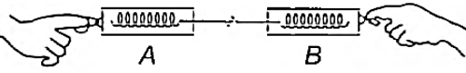  a) Zero  b) 2.5 N  c) 3.0 N  d) 1.5 N | [1]
23 | On a 3 kg mass, 5 newton of force acts for 0.1 second. The impulse imparted to the mass is (in kg m/s):  a) 0.16  b) 1.0  c) 1.5  d) 0.5 | [1]
24 | The acceleration of a body has to be doubled without any change in force. Then one has to  a) decrease the mass to half  b) increase the mass by half  c) double the mass  d) cannot be made | [1]
25 | According to second law of Newton, force is the cause and the outcome is:  a) time  b) velocity  c) momentum  d) acceleration | [1]
26 | In a rocket, fuel burns at the rate of 1 kg s$​^{−1}$ . This fuel is ejected from the rocket with a velocity of 60 km s $​^{−1}$ . This exerts a force on the rocket equal to  a) 6000 N  b) 600 N  c) 60000 N  d) 60 N | [1]
27 | A motorcycle and a car are moving on a horizontal road with the same velocity. If they are brought to rest by the application of brakes, which provided equal retardation, then  a) Both will stop at the same distance  b) Car will stop at a shorter distance  c) Nothing can be predicted.  d) Motorcycle will stop at shorter distance | [1]
28 | Which of the following statement is not correct for an object moving along a straight path in an accelerated motion?  a) Its velocity always changes  b) A force is always acting on it  c) It speed keeps changing  d) It always goes away from the earth | [1]
29 | The two states of motion treated alike by Newton’s first law, among A, B, C, and D areA : Rest B: Uniform motion C: Uniformly accelerated. D : Non - uniformly accelerated  a) A, D  b) A, C  c) B, C  d) A, B | [1]
30 | Which of the following has the largest inertia?  a) your physics book  b) a pin  c) your school bag  d) a pen | [1]
31 | In the first second of its flight, a rocket ejects$\frac{1}{40}$ of its mass with a velocity of 1200 m s $​^{−1}$ . The acceleration of the rocket is  a) 40 m s$​^{−2}$  b) 60 m s$​^{−2}$  c) 30 m s$​^{−2}$  d) 20 m s$​^{−2}$ | [1]
32 | The one which has the least inertia among the following: 1 kg stone, 2 kg ball, a train compartment and a cup of tea is  a) 2 kg ball  b) 1 kg stone  c) a train compartment  d) a cup of tea | [1]
33 | A passenger in a moving train tosses a coin which falls behind him. It means that motion of the train is  a) along circular tracks  b) uniform  c) accelerated  d) retarded | [1]
34 | The minimum number of unequal forces that can make zero resultant is  a) ten  b) four  c) three  d) two | [1]
35 | A bullet of mass 10 g is fired from a rifle. The bullet tales 0.003 second to move through its barrel and leaves it with a velocity of 300 m/s. What is the force exerted on the bullet by the rifle?  a) 250N  b) 1000 N  c) 400N  d) 200N | [1]
36 | When no external force acts on an object, the physical quantity that remains conserved is  a) force  b) momentum  c) acceleration  d) velocity | [1]
37 | Action reaction forces act:  a) on the same body  b) on different bodies  c) in the same direction  d) along different bodies | [1]
38 | Fireman holds a hose by exerting a _____.  a) momentum  b) friction  c) force  d) an acceleration | [1]
39 | A force of 5 N gives a mass m$​_{1}$ an acceleration of 10ms $​^{−2}$ and mass m $​_{2}$ an acceleration of 20 ms $​^{−2}$ . What acceleration would if give it both the masses were tied together?  a) 7.65 ms$​^{−2}$  b) 7.00 ms$​^{−2}$  c) None of these  d) 6.67 ms$​^{−2}$ | [1]
40 | The SI unit of force is:  a) Newton  b) Newton per second  c) Newton per square metre  d) Newton metre | [1]
41 | A player caught a cricket ball of mass 200 g moving at a rate 60 m/s. If the catching process completes in 0.4 s, the force of the blow exerted by the ball on the hand of the player is equal to  a) 300 N  b) 30 N  c) 150 N  d) 3 N | [1]
42 | A plate, a ball and child all have the same mass. The one having more inertia is the  a) child  b) plate  c) All have equal inertia  d) ball | [1]
43 | Which of the following is the velocity - time graph of a moving particle on which net external force is zero?  a) 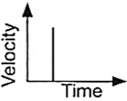  b) 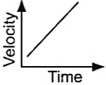  c) 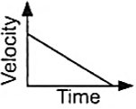  d) 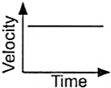 | [1]
44 | The change in the momentum of a body in 0.01 seconds is 10 kg ms$​^{−1}$ . The force acting on this body is  a) 100 N  b) 0.1 N  c) 10 N  d) 1000 N | [1]
45 | A force can be completely described by:  a) its magnitude  b) neither magnitude nor direction  c) its magnitude and direction  d) its direction | [1]
46 | Two blocks made of different metals identical in shape and size are acted upon by equal forces which cause them to slide on a horizontal surface. The acceleration of the second block is found to 10 times that of the first. What is the ratio of the mass of the second to the first?  a) 1 : 5  b) 1 : 1  c) 1 : 10  d) 10 : 1 | [1]
47 | A cup of water holding a steel ball (m) is allowed to fall under gravity. The reaction between the ball and the base of the cup is  a) $\frac{mg}{2}$  b) zero  c) mg  d) 2mg | [1]
48 | Three identical bodies each of mass m, are pushed by a force F on a frictionless table as shown in figure. 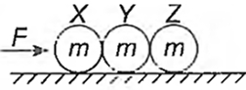  a) Net force on X is F.  b) Net force on Y is equal to zero.  c) Force applied by Y on Z is equal to net force on X.  d) Force applied by X on Y is$\frac{F}{3}$ . | [1]
49 | An object of mass 2 kg is sliding with a constant velocity of 4ms$​^{−1}$ on a frictionless horizontal table. The force required to keep the object moving with the same velocity is  a) 32 N  b) 2 N  c) 0 N  d) 8 N | [1]
50 | While catching a stone thrown by your friend you pull the hands back to  a) avoid the breaking of the stone  b) avoid getting hurt  c) increase the time to slow down  d) decrease the time to slow down | [1]
51 | Impulse has the S.I. unit of ______  a) newton  b) N - s  c) joule  d) m/s$​^{2}$ | [1]
52 | A goalkeeper in a game of football pulls his hands backwards after holding the ball shot at the goal. This enables the goalkeeper to  a) reduce the force exerted by the ball on hands  b) exert larger force on the ball  c) increase the rate of change of momentum  d) decrease the rate of change of momentum | [1]
53 | A truck carries sand. Due to hole in the base of truck, significant amount of sand falls continuously. For the same condition of working of the engine, the speed of the truck should  a) increase  b) cannot be found  c) remain the same  d) decrease | [1]
 | Section B
54 | What does the given image illustrate?   a) Second law of motion  b) Law of conservation of momentum  c) Third law of motion  d) First law of motion | [1]
55 | Which effect of force is observed in the given image?   a) A force can change the speed of a moving body  b) A force can change the shape of the object  c) A force can move a stationary body  d) A force can stop a moving body | [1]
56 | The given image correlates with which law of motion? 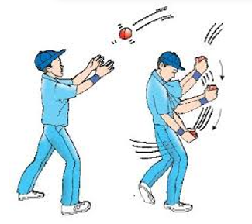  a) First law of motion  b) Second law of motion  c) Law of momentum  d) Third law of motion | [1]
57 | In the given below image, the goalkeeper held his palm in the path of the moving ball to show that 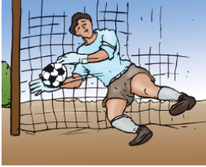  a) A force can change the speed of a moving body  b) A force can move a stationary body  c) A force can stop a moving body  d) A force can change the shape of the object | [1]
58 | The image shows a force which always opposes the motion of one body over another body. This is: 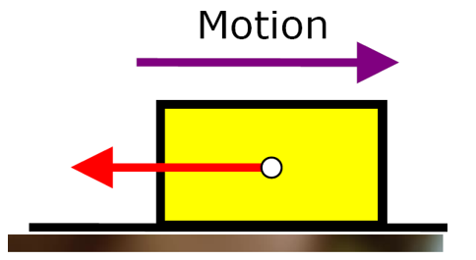  a) Gravitational force  b) Frictional force  c) Electrostatic force  d) Magnetic force | [1]
59 | The image shows the firing of a gun. What happens when a gun is fired? 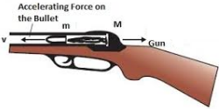  a) Exerts a backward force on the bullet  b) Exerts a forward force on the arm  c) Exerts a forward force on the bullet  d) None of these | [1]
60 | When we press a rubber ball with both the hands, it 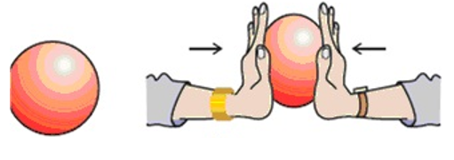  a) becomes light  b) None of these  c) changes composition  d) changes its shape | [1]
61 | The v - t graph of a body of 5 kg moving with the help of a force is shown. Then the force involved is 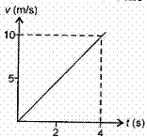  a) 12.5 N  b) 2.0 N  c) 20 N  d) 125 N | [1]
62 | The given image shows an effect of force that it can 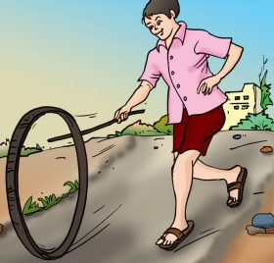  a) Change the shape of the object  b) Move a stationary object  c) Stop a moving object  d) Change the size of the object | [1]
63 | As the sailor jumps forward out of a rowing boat, the force on the boat moves it backward. This is an example of 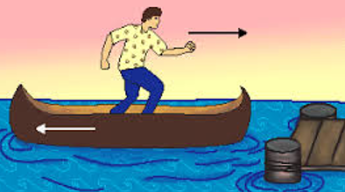  a) law of conservation of momentum  b) second law of motion  c) first law of motion  d) third law of motion | [1]
 | Section C
64 | A gun recoiled to ___________ the momentum.  a) decrease  b) conserve  c) increase  d) change | [1]
65 | Inertia is of _________ types.  a) three  b) four  c) two  d) one | [1]
66 | Balanced forces may ________ a body.  a) Accelerated  b) Move  c) Retard  d) Deform | [1]
67 | Newton’s first law gives the ________ definition of force.  a) quality  b) quantitative  c) qualitative  d) None of these | [1]
68 | Newton’s third law tells that ________force does not exist.  a) motion  b) isolated  c) movement  d) momentum | [1]
69 | The total ________contained in a body is called momentum.  a) none of these  b) momentum  c) fat  d) motion | [1]
70 | The rate of change of momentum is ________to the applied force.  a) indirect proportional  b) correct proportional  c) directly proportional  d) None of these | [1]
71 | A high jumper runs for a while before taking high jump so that the inertia of ________help him in taking a long jump.  a) shape  b) direction  c) rest  d) motion | [1]
72 | Leaves get detached from a tree due to ________.  a) conservation of momentum  b) change in momentum  c) acceleration  d) inertia | [1]
73 | If no external force acts on a system of particles then the ________ of the system remains conserved.  a) movement  b) inertia  c) momentum  d) motion | [1]

